What are TestNG listeners?

Below is an example of TestNG listner for ‘ItestListener’. Here, we have define a customer listener class which implements ‘ITestListener’ interface which provides multiple methods and one of the is ‘OnTestFailure’ which will be automatically called once the test case is failed.

Three test cases are desined in test class where they are intentionally marked as failure. Hence, these @Test methods are tests so ‘OnTestFailure’ method will be called every time each of @Test annotation method got failed. For example, if first @Test annotation is failed then automatically ‘OnTestFailure’ will be called and so holds true for second and third @Test automation methods.

**Conclusion is that ‘OnTestFailure’ or ‘onTestPass’ or any other methods of ‘ITestListener’’ will be executed as per the status (pass or fail) of @Test annotation method.**

**We also conclude that ‘ITestListener’ listener methods are executed after running of @Test Annotation methods.**

**In below example, there are 3 @Test annotation and all are intentionally marked failure so 3 time ‘OnTestFailure’ method of ‘ITestListener’ interface will be called. ITestListener’ defined in customListner class is defined at the top.**

1. **Test Class**

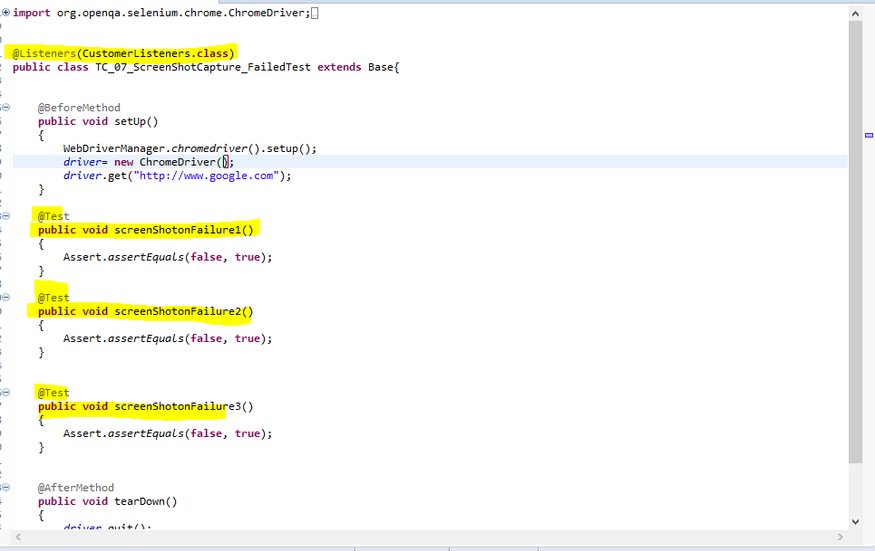

1. **CustomListners class:**

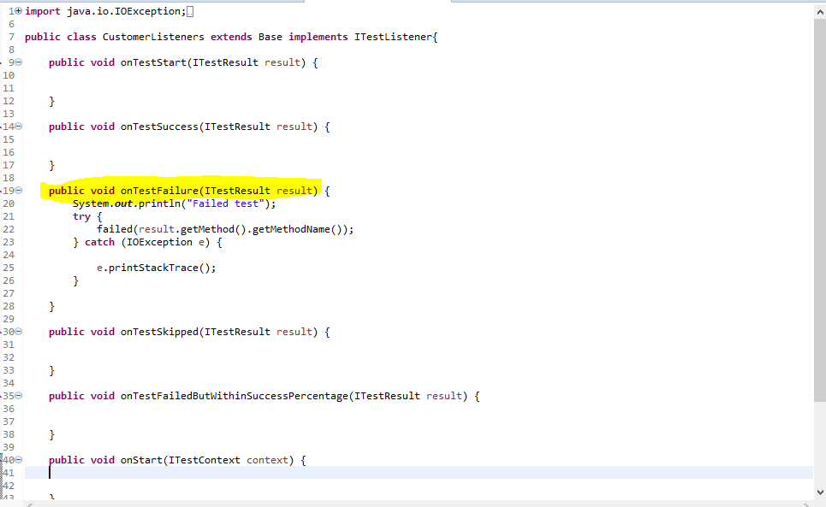

1. **BaseClass**

